Hector Pena
DSC 680
Bellevue University
EV Charging Station Analysis
Business Problem:
With the growing popularity of Electric Vehicle (EV) we need more EV charging stations to be built across the United States this project will take a deep dive into EV Charging stations. For the consumers they want to see a breakdown of the EV charging stations so they can make an informed decision as to if having an Electric Vehicle is a smart choice for them. An analysis that emphasizes the reliability of these charging stations and the networks which own said charging stations, will try to answer the questions of how reliable the charging stations are. With the vast majority or charging stations being outside there is a possibility that external factors may affect the reliability.
Background:
When looking back at the late 1800’s we can see the introduction of electric vehicles, which brings the experimentation of vehicle charging. In the early forms of experimentation EV had removable batteries that had to be changed manually or at battery stations. Moving to the 19th and early 20th century the sales of EV increased in popularity owners have started installing EV chargers at their homes, public charging stations have become more accessible.
Late 20th century shows us automakers experimenting with EVs especially in the state of California. The 2000’s showed the first charger capable of fully charging EVs in several hours.
With the expansion of vehicle manufactures launching more EV; such as Nissan Leaf. Tesla Model S, etc. The charging infrastructure expanded rapidly causing companies and government to invest in networks of chargers across cities.
Data Explanation:
The data we will be using for this project has been collected from Kaggle, this dataset provides 33 different metrics that range in category. This dataset will help us see metrics such as time, location, average charge time, type of chargers, number of ports, etc. which we can use to show EV owners any trends or useful information to make educated decisions on their EV charging needs. To get the most of our data we must perform basic EDA to remove any irregularities in our data as well as fill any null values that may be in place. We will also filter our data to segment it by columns so we can get a closer look at certain metrics.
Methods:
With this dataset we have a wide range of potential of many types of analysis, with the metrics listed in this dataset we can run a Time Series Forecasting. This will predict EV station availability and peak demand hours. With using classification, we can determine if a charger will be available at a given time. With running a regression model, we can try to predict utilization rates and wait times for EV stations. A clustering model can be used to segment stations by usage patterns and location type. By running anomaly detection, we can try to identify maintenance issues or unusual demand spikes that affect EV stations. With a correlation analysis, we can explore relationships between weather, gas prices, traffic, and EV charging demand. With the use of dynamic pricing optimization, we can model pricing strategies based on demand patterns. With the use of visualizations, we can create a compelling EV infrastructure dashboards and maps to show consumers different metrics. With all these methods we can help to identify underserved areas and optimize locations for new EV charging stations.
Analysis:
After using the methods from above we can see the distribution of charger types showing that over 40 percent of our chargers are DC fast chargers while Tesla DC-Fast only take up around 14 percent of charger types. Below we can see the breakdown of our charger types.
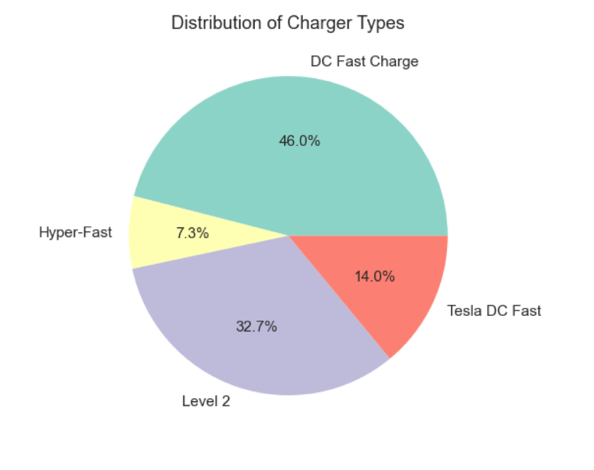
Looking into the location of these chargers we can see that most chargers falling under the airport category compared to Residential chargers that take up around 70 percent of locations. We can see the breakdown below showing our Charging Station Locations.
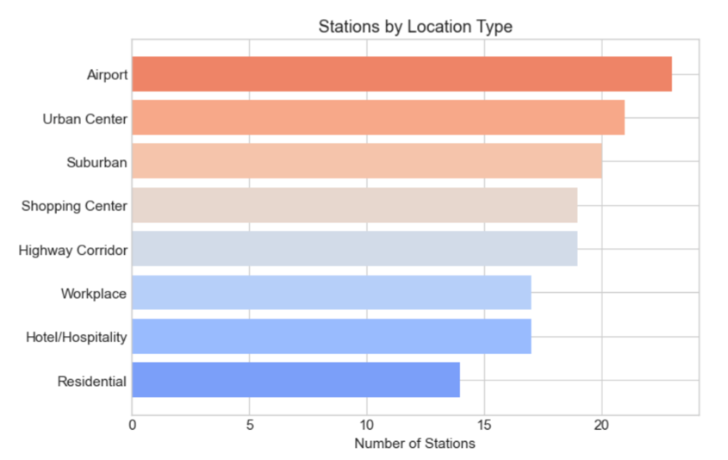
Lastly we can see the utilization rate of EV chargers regarding weather conditions, we can see that most of the utilizations for EV charges seem to be when weather conditions are freezing and there is a decrease in utilization when weather conditions are heavy rain. We can see the breakdown a breakdown of the Utilization by Weather Condition.
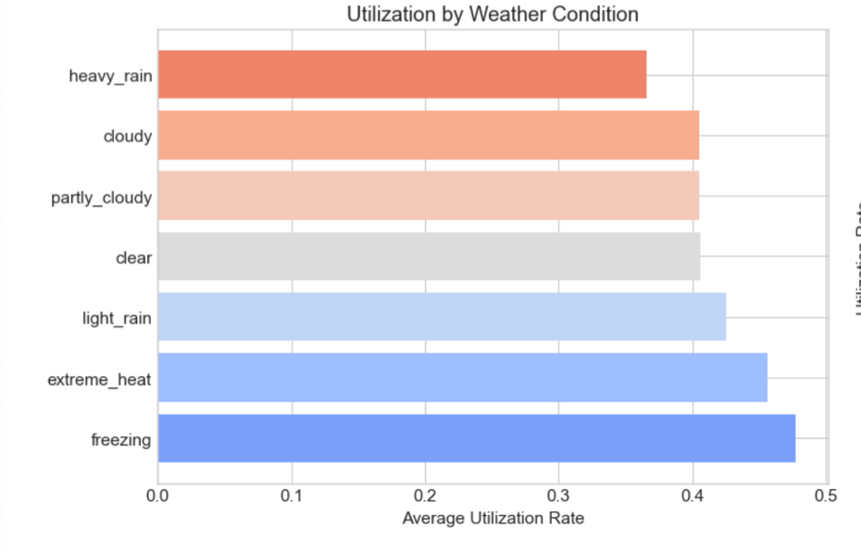
With using a correlation analysis that focuses on the utilization rate of the parameters we can see that we have a MAE close to zero which shows a good correlation analysis. While our R^2 is not the strongest in the following Correlation Analysis we will add parameters to help improve our score. Focusing on Charger Type and Network Type we can see a change in the correlation analysis. This slight change in the MAE RMSE and R^2 shows us a meaningful lift just by adding these two structured categorical features. Below we can see the MAE, RMSE, and R^2 for the target utilization rate without using charger type and network type versus using these parameters.
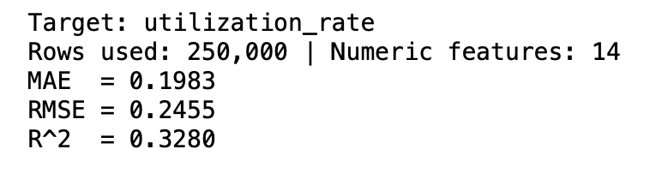
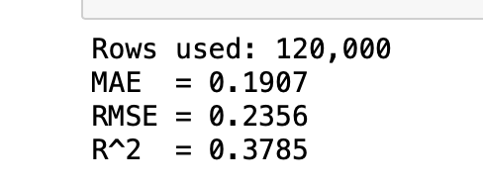

Conclusion:
We can see that popularity of EV charging stations has grown and the infrastructure must continue to grow with it. With manufacturers moving their vehicle models to offer Plug-in EV models the opportunity to own an EV has become more accessible for the consumers the EV charger networks to keep up with the growing popularity of EVs. With looking into utilization rates, we can see that most people would rather to charge their vehicle during freezing weather rather than clear weather.
Challenges/Issues:
The one topic that may bring some pushback is that use and increase of Electric Vehicles may have a negative impact to our climate, while others may argue that taking gas powered vehicles off the roads has a greater impact on climate. This is a major topic for debate and can impact the way consumers think of Electric Vehicles, and their charging stations. Which may affect the purchase of EV as well as hinder the improvement and construction of new EV charging stations. Utilization for EV Chargers is driven primarily by network ecosystem effects, charger type, and time-of-day traffic patterns. Network brand differences explain more variation than weather or geography. Fast charging networks show significantly higher utilization.

Ethical Considerations:
The data provided in this dataset does not closely tie with any specific personal information; it is public information therefore it does not violate any ethical concerns.
Recommendations:
For the infrastructure of EV charging stations, the networks must take into account what their consumers want and use that to revamp existing charging stations and include amenities that consumers will like for any future building of EV stations.
Questions Asked by Consumers:
- What EV charging type should I use?
  - Looking at the distribution of charger type, we can see that DC Fast Charger takes up the most chargers in the distribution. This shows us that this network of chargers will be the ones most EV drivers will use.
- What is the average time of waiting for a charger at the charging station?
  - The average wait time for EV chargers range from location to location, the lowest time is 1.299 in Minneapolis while the highest is 3.720 in San Diego.
- What is the best network for EV chargers?
  - The leading network for EV chargers is Electrify America; this network of chargers has the most available charging stations for consumers making it one of the best for EV owners.
- What charging station should I avoid?
  - EVgo charging network has the lowest number of chargers available, about 1/4th the amount of chargers than the leader Electrify America. This may be a charging network we may want to avoid.
- What weather conditions affect EV charger station foot traffic?
  - Most EV users avoid the charging stations when the weather is heavy rain, but when it is freezing the utilization increase more than average in comparison to a clear day.
- What is the average time for charging at the different types of networks?
  - The average time depends on the charger type if it is a fast charger, and the location of the network as well, as some cities have more readily available chargers than others.
- What are the benefits of owning a EV versus a gasoline vehicle?
  - The price of charging your EV is less than the price of filling it up with gasoline, the price of maintenance for a gasoline engine vehicle is more than the average maintenance for a EV vehicle.

References:
Kurti, A. (2024, May 28). History of electric charging stations: A journey through time between innovation and sustainability. Free To X - PROD. https://freeto-x.it/en/article/history-of-electric-connectors/?utm_source=chatgpt.com
Rodolfo. (2023, September 30). The history of EV charging infrastructure - EZ EV Electric. EZ EV Electric - EZ EV Electric Helping You Install And Launch Smart Electric Vehicle Charging Stations. https://www.ezevelectric.com/the-history-of-ev-charging-infrastructure/
Wikimedia Foundation. (2026a, January 17). Chargepoint. Wikipedia. https://en.wikipedia.org/wiki/ChargePoint?utm_source=chatgpt.com
Wikimedia Foundation. (2026, January 28). SAE J1772. Wikipedia. https://en.wikipedia.org/wiki/SAE_J1772?utm_source=chatgpt.com

